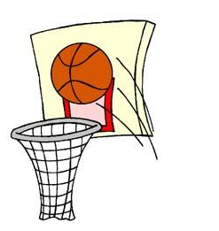
EPPJ 3 on 3 Basketball Tournament
Saturday, June 13, 2015
St. Boniface Gym & Courts, Elgin, NE

Registration form and $75 fee must be received by Monday, June 8, 2015 and can be sent to EPPJ 3 on 3, PO Box 284, Elgin, NE 68636. Checks can be made to Wolfpack Boys Basketball. For questions, please call Scott Becker: 402-640-5154.
*Half-court games *Double Elimination Bracket *16 point games, 20 minute time limit *Winners in each bracket will receive a T-shirt

Team Name: __________________________________________________

Circle Division:
9:00 a.m. to 12:00 p.m.: Grades 3-5 Girls Grades 3-5 Boys Grades 6-8 Girls Grades 6-8 Boys
1:00 p.m. to 4:00 p.m.: Grades 9-12 Girls Grades 9-12 Boys Adult Division Family Division
Player Signature OR
Parent Signature if
Name City Phone and Email Grade (2015-16) player is under 18 (see waiver below)
Captain
Player 2
Player 3
Player 4
Player 5
Participant Release and Waiver: I acknowledge that competing in a sporting event is a test of a person’s physical and mental limits. By signing above, I assume the risks for myself or my child in participating in this event. I agree that I will not hold EPPJ Boys Basketball, its staff, volunteers, nor St. Boniface Parish or School liable for any loss, damage or injury while playing at the EPPJ 3 on 3 Basketball Tournament.

