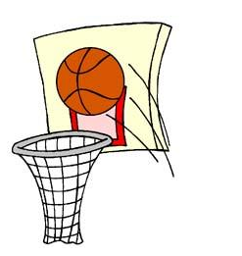
EPPJ 3 on 3 Basketball Tournament
Saturday, July 30, 2016
Elgin, NE

Registration form and $80 fee must be received by Tueday, July 26, 2016 and can be sent to EPPJ 3 on 3, PO Box 284, Elgin, NE 68636. Checks can be made to Wolfpack Boys Basketball. For questions, please call Scott Becker: 402-640-5154.
*Half-court games *Pool Play - Double Elimination Bracket *16 point games, 20 minute time limit *Winners in each bracket will receive a T-shirt

Team Name: __________________________________________________

Circle Division:
8:00 a.m. to 12:00 p.m.: Grades 3-5 Girls Grades 3-5 Boys Grades 6-8 Girls Grades 6-8 Boys
1:00 p.m. to 5:00 p.m.: Grades 9-12 Girls Grades 9-12 Boys Adult Division Family Division
Player Signature OR
Parent Signature if
Name City Phone and Email Grade (2016-17) player is under 18 (see waiver below)
Captain
Player 2
Player 3
Player 4
Player 5
Participant Release and Waiver: I acknowledge that competing in a sporting event is a test of a person’s physical and mental limits. By signing above, I assume the risks for myself or my child(ren) in participating in this event. I agree that I will not hold EPPJ Boys Basketball, its staff, volunteers, St. Boniface Parish or School, Pope John School, Elgin Public School, nor the city of Elgin liable for any loss, damage or injury while playing at the EPPJ 3 on 3 Basketball Tournament.

