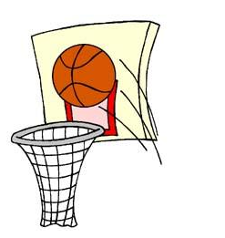
EPPJ 3 on 3 Basketball Tournament
Saturday, July 1, 2017
Elgin, NE

Registration form and $60 fee must be received by Saturday June 17th, 2017 and can be sent to EPPJ 3 on 3, PO box 399, Elgin, NE 68636. Checks can be made to Wolfpack Boys Basketball. For questions, please call Michael Becker: 402-649-8888
*Half-court games *Pool Play - Double Elimination Bracket *16 point games, 20 minute time limit *Winners in each bracket will receive a T-shirt (money back in adult division)

Team Name: __________________________________________________

Circle Division:
8:00 a.m. to 12:00 p.m.: Grades 3-5 Girls Grades 3-5 Boys Grades 6-8 Girls Grades 6-8 Boys
1:00 p.m. to 5:00 p.m.: Grades 9-12 Girls Grades 9-12 Boys Adult Division
Player Signature OR
Parent Signature if
Name City Phone and Email Grade (2017-18) player is under 18 (see waiver below)
Captain
Player 2
Player 3
Player 4
Player 5
Participant Release and Waiver: I acknowledge that competing in a sporting event is a test of a person’s physical and mental limits. By signing above, I assume the risks for myself or my child(ren) in participating in this event. I agree that I will not hold EPPJ Boys Basketball, its staff, volunteers, School, nor the city of Elgin liable for any loss, damage or injury while playing at the EPPJ 3 on 3 Basketball Tournament.

